**WEB AND MULTIMADIA DEVELOPMENT**

**Oabile Mompati Chere**

**CSE21-027**

**1. Website Specifications:** [10 marks]

a. State the website objective, its goals in relation to the business.

*To make resources of business easily reachable. A website is design to offer business products to users by easily accessing them thorough any computer or mobile device. So this profit a business as users will easily access business products.

*To continuously hold the business on run. A website is one of a portable media platform that runs continuously through internet connection hence being business beneficial as users will be able to access information anytime and anywhere.

b. State the target audience, showing their demographics and technical aptitude.

*Website’s target audience for movies theater ranges from people of 20 years to 50 years, looking at the potential use and understanding of websites along with who usually visit theater site. Fig 1.0 shows demographics of the target audience, people who ages from 20 – 30 takes 60% usage of the website followed by ages of 31 – 40 who’s usage is 30% then ages from 41 to 50 who’s usage is 10%. This shows that ages from 20 – 30 audience are the one’s with technical aptitude as they are the one’s with better understanding of using web.

c. You must identify the type of website or content you will be designing for the users

*As the website deal with movies theater, it should offer all relevant services that should be offered to the audience remotely as a way of simplifying, promoting and marketing the movies theater site. The website should update the users about movies and the time they will be played.

**2. Information Design & Taxonomy:**

3. Page Template Design:

**4**

The website will be made through HTML5 along with style CSS and java script. Tool to be used is Lucid chart for wireframe planning. Images for on the website to give users clue on what the site is about and video clips for trailers to give the user the idea of is being offered.

5.

Index page

Link pages

*About EMT

*Action movie page

*Horror movie page

*Romance Comedy movies

*UpComingMovies

*Contacts

*Feedback

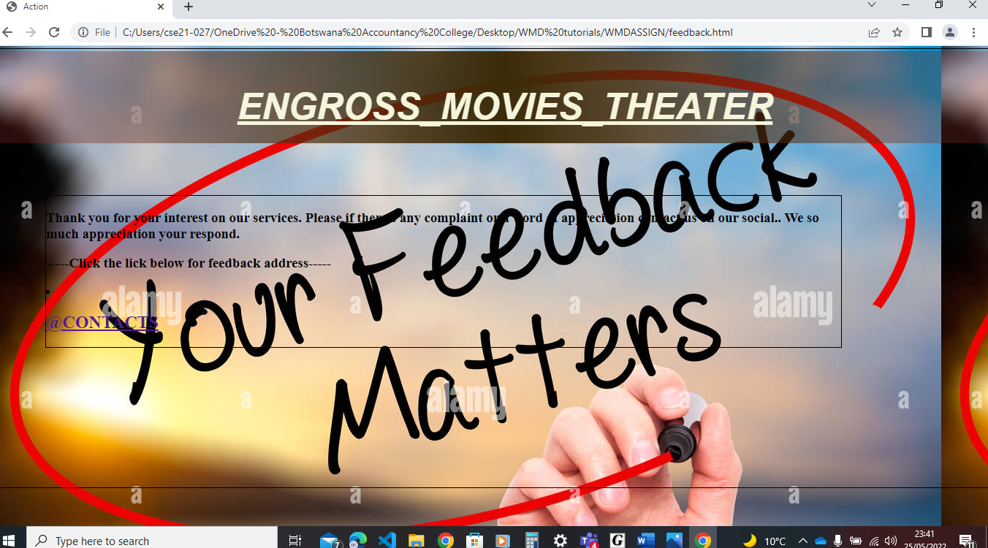

6

How I published my website in GitHub

https://github.com/cse21-027/WMDfinalassignment.git

7.

How to improve my website.

*Improving website capabilities to display on different media devices.

*Upgrading with more services like paying movie tickets